# **<TITLE OF THE PROJECT>**

QUIZ APPLICATION

MINI PROJECT REPORT

Submitted in partial fulfilment of the

Requirements for the award of the Degree of

BACHELOR OF ENGINEERING

IN

INFORMATION TECHNOLOGY

By

<R. Anish ><1602-20-737-005 >

<T. Shreya Reddy><1602-20-737-041 >

<T. Vishnu Vardhan Reddy ><1602-20-737-060 >



Department of Information Technology

Vasavi College of Engineering (Autonomous)

ACCREDITED BY NAAC WITH 'A++' GRADE

(Affiliated to Osmania University and Approved by AICTE)

Ibrahimbagh, Hyderabad-31

2022

Vasavi College of Engineering (Autonomous)

ACCREDITED BY NAAC WITH 'A++' GRADE

(Affiliated to Osmania University and Approved by AICTE)

Hyderabad-500 031

Department of Information Technology



DECLARATION BY THE CANDIDATE

We, <R. Anish >, <T. Shreya Reddy >, and <T. Vishnu Vardhan Reddy >, bearing hall ticket numbers, <1602-20-737-005 >, <1602-20-737-041> and <1602-20-737-060 >, hereby declare that the project report entitled <”QUIZ APPLICATION” > is submitted in partial fulfilment of the requirement for the award of the degree of Bachelor of Engineering in Information Technology

This is a record of bonafide work carried out by us and the results embodied in this project report have not been submitted to any other university or institute for the award of any other degree or diploma.

<R. Anish >

<1602-20-737-005 >

<T. Shreya Reddy>

<1602-20-737-041 >

<T. Vishnu Vardhan Reddy >

<1602-20-737-060 >

(Faculty In-Charge)

(Head,Dept of IT)

ACKNOWLEDGMENT

We extend our sincere thanks to Dr. S. V. Ramana, Principal, Vasavi College of Engineering for his encouragement.

We express our sincere gratitude to Dr. K. Ram Mohan Rao, Professor & Head, Department of Information Technology, Vasavi College of Engineering, for introducing the Mini-Project module in our curriculum, and also for his suggestions, motivation, and co-operation for the successful completion of our Mini Project.

We also want to thank and convey our gratitude towards our mini project coordinators

<Mrs. Divya L>,<Mrs.Rajya Lakshmi S> for guiding us in understanding the process of project development & giving us timely suggestions at every phase.

We would also like to sincerely thank the project reviewers for their valuable inputs and suggestions.

**Abstract**

Quiz Application is a collection of different questions. A user can play the quiz and attempt questions. There will be a limited number of questions and for each correct answer user will get a credit score. The purpose of Quiz Application is to take quizzes in an efficient manner and no time wasting for evaluating the marks. The main objective of this application is to efficiently evaluate the user through a fully automated system that not only saves a lot of time but also gives fast results. The system carries out the quiz and auto-grading for multiple choice questions which is fed into the system. Design of this project is pretty simple so that the user won’t find any difficulties while working on it.

TABLE OF CONTENTS

|  |  |  |
| --- | --- | --- |
| S.No. | Content | Page No. |
| 1 | Introduction | 6 |
| 2 | Technology | 7 |
| 3 | Proposed work | 8 |
| 4 | Implementation | 9-19 |
| 5 | Results | 20 |
| 6 | Additional learning | 22 |
| 7 | Future Scope | 23 |

INTRODUCTION

Our project is a console application which will be helpful to students where they can attempt quizzes, testing one’s knowledge power in the given examination. It can let students take exams digitally and improves skill. The system makes easier by providing quiz automatically for students. Using this system you can eventually take an exam by answering the provided questions.

The quiz application that we have built is a basic application that contains all features. This project is made in Python programming language.

This application provides facility to play online quiz and practice. It provides a good platform, where a student can judge their knowledge and also improve knowledge at the same time.

Building this project involved many methods in a specific order.

* Creating frame
* Adding questions
* Allowing user to select options
* Calculating score
* Display Score

TECHNOLOGY

To implement any project successfully, there will be technological requirements which can either be software or hardware requirements.

**Software requirements**:

Since our project was supposed to be based on the Python programming language, it is a bare necessity to have the knowledge and syntaxes of the language and a proper compiler. This code can be run in python IDLE shell(Version 3.3or higher), Windows 7 or above.

**Hardware requirements:**

• Minimum RAM required: 512 mb

• Minimum disk space required: 50 mb

• Input devices: Mouse, Keyboard

• Output devices: Monitor

**Proposed work**

a)Design

1. Use case diagram:

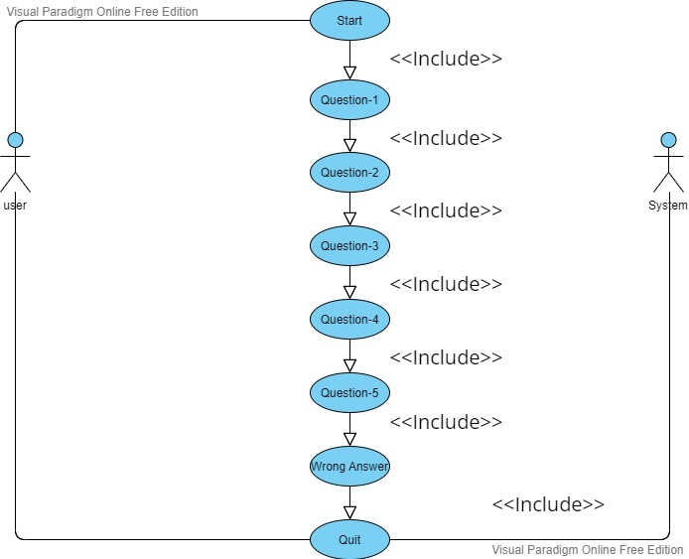

2.Activity Diagram:

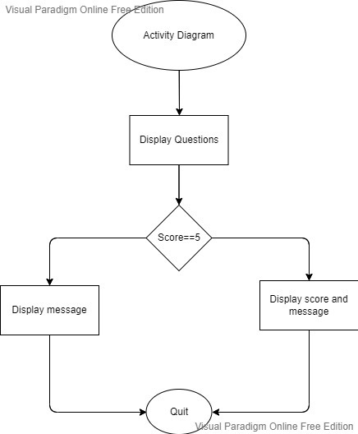

b) Implementation:

Source code:

Quiz.py

# the json module to work with json files

import json

import tkinter

from tkinter import *

import random

# load questions and answer choices from json file instead of the file

with open('./data.json', encoding="utf8") as f:

data = json.load(f)

# convert the dictionary in lists of questions and answers_choice

questions = [v for v in data[0].values()]

answers_choice = [v for v in data[1].values()]

answers = [2,1,3,1,0,1,2,0,3,3]

user_answer = []

indexes = []

def gen():

global indexes

while(len(indexes) < 5):

x = random.randint(0,9)

if x in indexes:

continue

else:

indexes.append(x)

def showresult(score):

lblQuestion.destroy()

r1.destroy()

r2.destroy()

r3.destroy()

r4.destroy()

global label,label1,label11,btn

label=Label(root,text="Your Score is",font="Verdana 24 bold",bg="#ffffff",fg="black",justify="center")

label.place(x=500,y=250)

label1=Label(root,text=score,font="Verdana 24 bold",bg="#ffffff",fg="black",justify="center")

label1.place(x=750,y=250)

if score!=5:

label11 = Label(root,text="/5",font="Verdana 24 bold",bg="#ffffff",fg="black",justify="center")

label11.place(x=775,y=250)

else :

label11=Label(root,text="/5",font="Verdana 24 bold",bg="#ffffff",fg="black",justify="center")

label11.place(x=800,y=250)

btn1 = Button(text="Quit",font="bold 18",bg="#FF0000",fg="black",command=root.destroy)

btn1.place(x=675,y=400)

def calc():

global indexes,user_answer,answers

x = 0

score = 0

for i in indexes:

if user_answer[x] == answers[i]:

score = score + 1

x += 1

print(score)

showresult(score)

ques = 1

def selected():

global radiovar,user_answer

global lblQuestion,r1,r2,r3,r4

global ques

x = radiovar.get()

user_answer.append(x)

radiovar.set(-1)

if ques < 5:

lblQuestion.config(text= questions[indexes[ques]])

r1['text'] = answers_choice[indexes[ques]][0]

r2['text'] = answers_choice[indexes[ques]][1]

r3['text'] = answers_choice[indexes[ques]][2]

r4['text'] = answers_choice[indexes[ques]][3]

ques += 1

else:

# print(indexes)

# print(user_answer)

# these two lines were just developement code

# we don't need them

calc()

def startquiz():

global lblQuestion,r1,r2,r3,r4

lblQuestion = Label(

root,

text = questions[indexes[0]],

font = ("Consolas", 16),

width = 500,

justify = "center",

wraplength = 400,

background = "#ffffff",

)

lblQuestion.pack(pady=(100,30))

global radiovar

radiovar = IntVar()

radiovar.set(-1)

r1 = Radiobutton(

root,

text = answers_choice[indexes[0]][0],

font = ("Times", 12),

value = 0,

variable = radiovar,

command = selected,

background = "#ffffff",

)

r1.pack(pady=5)

r2 = Radiobutton(

root,

text = answers_choice[indexes[0]][1],

font = ("Times", 12),

value = 1,

variable = radiovar,

command = selected,

background = "#ffffff",

)

r2.pack(pady=5)

r3 = Radiobutton(

root,

text = answers_choice[indexes[0]][2],

font = ("Times", 12),

value = 2,

variable = radiovar,

command = selected,

background = "#ffffff",

)

r3.pack(pady=5)

r4 = Radiobutton(

root,

text = answers_choice[indexes[0]][3],

font = ("Times", 12),

value = 3,

variable = radiovar,

command = selected,

background = "#ffffff",

)

r4.pack(pady=5)

def startIspressed():

labelimage.destroy()

labeltext.destroy()

btnStart.destroy()

gen()

startquiz()

root = tkinter.Tk()

root.title("Quiz Game")

root.geometry("700x600")

root.config(background="#ffffff")

#root.resizable(0,0)

img1 = PhotoImage(file="Quiz Game.png")

labelimage = Label(

root,

image = img1,

background = "#ffffff",

)

labelimage.pack(pady=(40,0))

labeltext = Label(

root,

text = "Quiz App",

font = ("Comic sans MS",24,"bold"),

background = "#ffffff",

)

labeltext.pack(pady=(0,10))

img2 = PhotoImage(file="Frame.png")

btnStart = Button(

root,

image = img2,

relief = FLAT,

border = 0,

command = startIspressed,

)

btnStart.pack()

#win=tkinter.Tk()

#win.title("Let's play Quiz")

#win.configure(bg="#FF0000")

#win.geometry("1350x700+0+0")

root.mainloop()

[

{

"1": "Who developed Python Programming Language?",

"2": "Which of the following functions takes A console Input in Python ?",

"3": "Which type of Programming does Python support ?",

"4": "Which of The Following is must to Execute a Python Code ?",

"5": "Is Python case sensitive when dealing with identifiers ?",

"6": "The append Method adds value to the list at the ?",

"7": "Which of the following is the correct extension of the Python file ?",

"8": "What will be the value of the following Python expression? 4+3%5",

"9": "Which of the following keyword is used to create a function in Python ?",

"10": "To Declare a Global variable in python we use the keyword ?"

},

{

"1": [

"Wick van Rossum",

"Rasmus Lerdorf",

"Guido van Rossum",

"Niene Stom"

],

"2": [

"get()",

"input()",

"gets()",

"scan()"

],

"3": [

"object-oriented programming",

"structured programming",

"functional programming",

"all of the mentioned"

],

"4": [

"TURBO C",

"Py Interpreter",

"Notepad",

"IDE"

],

"5": [

"no",

"yes",

"machine dependent",

"none of the mentioned"

],

"6": [

"custom location",

"end",

"center",

"beginning"

],

"7": [

".python",

".pl",

".py",

".p"

],

"8": [

"7",

"2",

"4",

"1"

],

"9": [

"function",

"void",

"fun",

"def"

],

"10": [

"all",

"var",

"let",

"global"

]

}

]

**Github repository**

https://github.com/AnishRamagalla/Quiz-Application

**Results:**

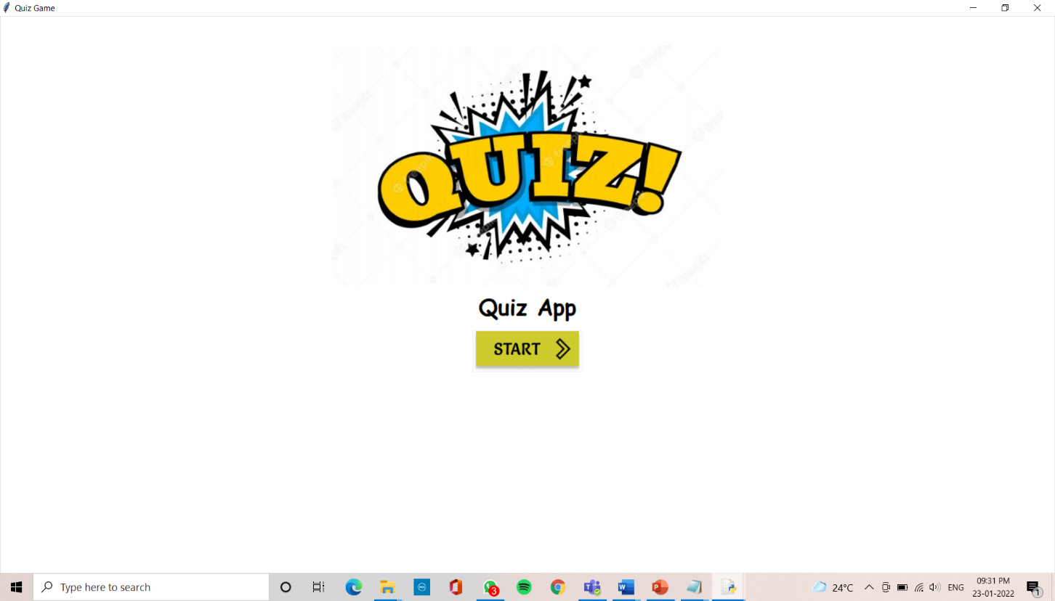

This is the output of the execution of the quiz application. Title is displayed.

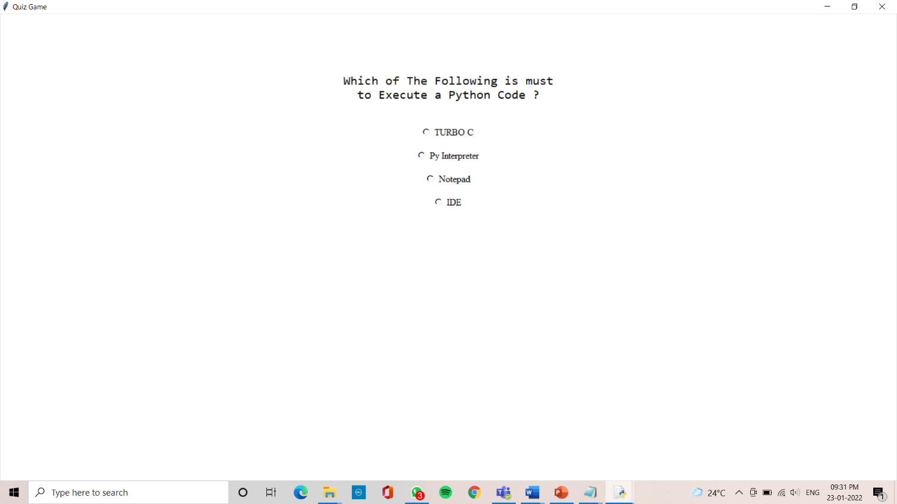

Questions are displayed when start button is clicked.

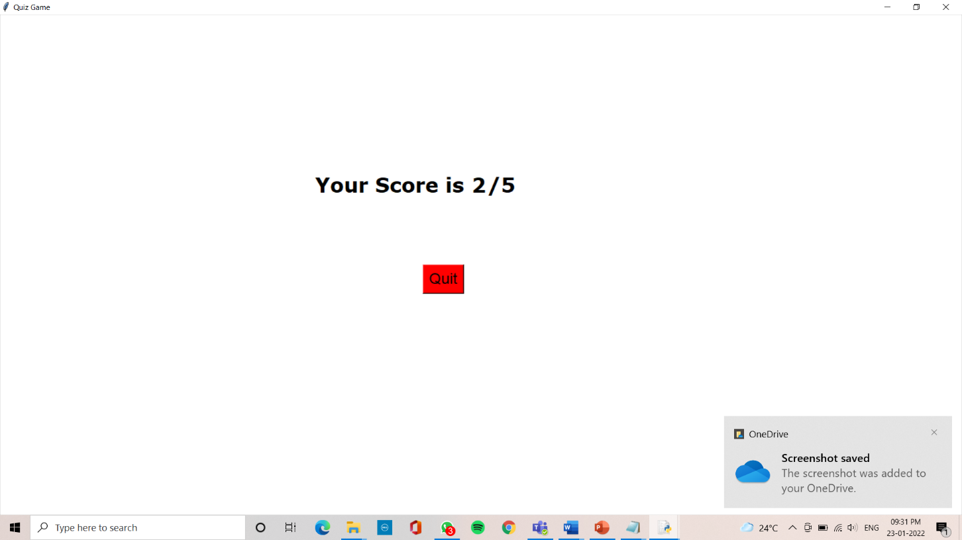

Results are displayed when all the questions are answered.

ADDITIONAL LEARNING

The way we learned to manage our time. Basically, time management of classes, assignments, quizzes, and other stuff was great learning not only professionally but also helped both of us to grow as individuals. This project helped both of us to put our interest in coding in a certain work and really helped it to grow. Not only time but also the workload had to be managed a lot because some of the assignments weren’t that time taking but were mentally really exhausting. Both of us had an amazing experience working together and we really understood the importance of teamwork which is something that helps you to increase your spread of thoughts due to various opinions help the work to complete in less time, in a more efficient manner.

Self-learning is another important aspect which we needed to explore in ourselves as there were few things which we didn’t know and we needed to take the help of google and needed to learn them by ourselves online. And this made the understanding of our project a lot easier and helped us to be more creative in various steps of its development. We also had to revise a lot of concepts regarding programming in Python, which made our basics even stronger and is helping us to be even more confident. We all knew that we use a text editor to generally write a program before compiling it. We were always keen on how a program is written and how it functions. This was the most interesting part of the project. We saw this as an opportunity to improve our skills rather than an assigned task which helped us to complete this project with more excitement and enthusiasm.

FUTURE SCOPE

We have a lot of plans that we would like to add a lot of elements to our project. We would like to add more file types like add admin and login pages so that only admin is allowed to add the questions. And also various questions related to different fields can be added.